What is VAMA?
Volatility Adaptive Moving Average means:
👉 When volatility is high → MA becomes faster
👉 When volatility is low → MA becomes slower
This makes VAMA:
- React quickly during fast markets
- Stay smooth and stable during quiet markets
A perfect blend of speed + stability.

Step | Logic
Trend | Price above/below VAMA
Long Entry | Price > VAMA
Short Entry | Price < VAMA
Long Exit | Price ≤ VAMA
Short Exit | Price ≥ VAMA
Position Size | 100 qty fixed

Volatility Adaptive Moving Average (VAMA) is a dynamic moving average that automatically adjusts its speed and sensitivity based on market volatility.
Unlike normal moving averages (SMA, EMA, WMA), VAMA does not use a fixed smoothing factor.
Instead, it uses a variable alpha (α) that expands or contracts depending on how volatile the market is.

MA Type | Speed | Problem
SMA | Very slow | Misses fast moves
EMA | Faster | Still slow during volatile markets
WMA | Fast | Too noisy in low volatility

Feature | SMA | EMA | VAMA
Adapts to volatility | ❌ No | ❌ No | ✔ Yes
Noise filtering | Medium | Medium | Excellent
Trend response | Slow | Medium | Fast when needed
Lag | High | Medium | Low
Suitability for algo trading | OK | Good | Excellent

Tick | Price
1 | 100
2 | 102
3 | 101
4 | 105
5 | 107
6 | 110
7 | 108
8 | 111
9 | 112
10 | 115
11 | 117
12 | 116
13 | 118
14 | 120
15 | 119
16 | 121
17 | 122
18 | 124
19 | 123
20 | 125

Calculate Mean
Sum of all 20 prices = 2296
Mean=2296/20=114.8

Price | Price – Mean | (Price–Mean)²
100 | –14.8 | 219.04
102 | –12.8 | 163.84
101 | –13.8 | 190.44
105 | –9.8 | 96.04
… | … | …
125 | +10.2 | 104.04

Sum of all squared deviations = ≈ 1160.2

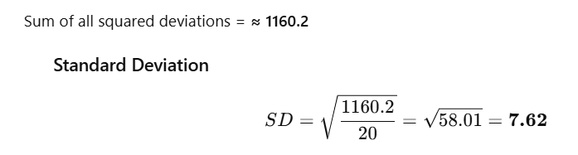

Very Important about alpha
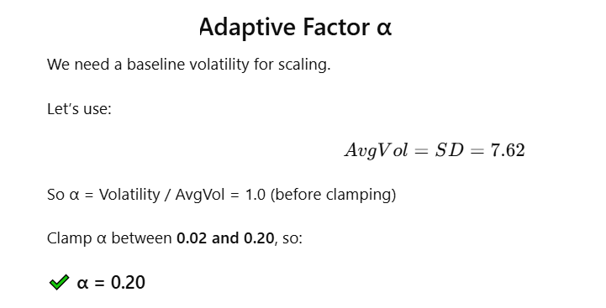

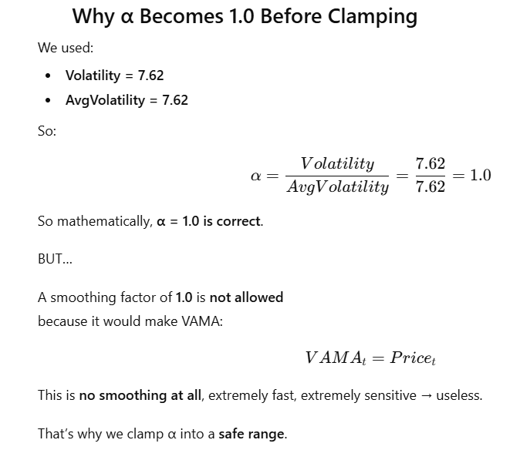

If α becomes too large:
- It reacts too fast
- Becomes noisy
- Behaves like a raw price instead of a moving average

α value | Meaning
0.02 | Very slow smoothing (low volatility)
0.20 | Fast smoothing (high volatility)
never above 0.20 | Prevents overreaction

Step | Value
Raw Volatility | 7.62
Average Volatility | 7.62
α (raw) | 1.0
α (after clamp) | 0.20 (maximum allowed)

Volatility | Raw α | Clamped α | Interpretation
Normal | 0.8 | 0.20 | Max speed allowed
Extremely high | 2.5 | 0.20 | Still capped
Low | 0.1 | 0.1 | Allowed, inside range
Very low | 0.01 | 0.02 | Minimum allowed

Keep α range = [0.02, 0.20] (standard)

Will α (alpha) change after the first 20 readings when price #21 arrives?
✅ Answer:
Yes.
α (the adaptive smoothing factor) will change when the 21st price arrives because VAMA recalculates volatility using the most recent 20 prices. As volatility increases or decreases, α automatically adjusts—becoming faster in high volatility and slower in low volatility. This dynamic recalculation is what makes VAMA an adaptive moving average.

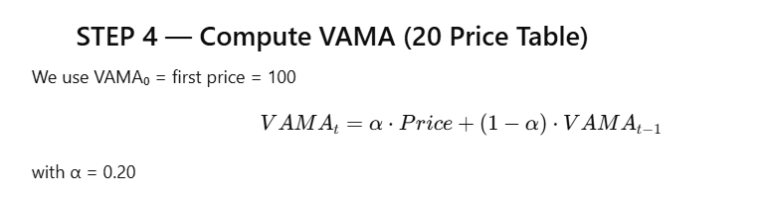

Tick | Price | α | VAMA Formula | VAMA Value
1 | 100 | – | Initial | 100.00
2 | 102 | 0.20 | 0.2×102 + 0.8×100 | 100.40
3 | 101 | 0.20 | 0.2×101 + 0.8×100.4 | 100.52
4 | 105 | 0.20 | 0.2×105 + 0.8×100.52 | 101.42
5 | 107 | 0.20 | 0.2×107 + 0.8×101.42 | 102.54
6 | 110 | 0.20 | 0.2×110 + 0.8×102.54 | 103.83
7 | 108 | 0.20 | 0.2×108 + 0.8×103.83 | 104.67
8 | 111 | 0.20 | 0.2×111 + 0.8×104.67 | 105.94
9 | 112 | 0.20 | 0.2×112 + 0.8×105.94 | 107.15
10 | 115 | 0.20 | 0.2×115 + 0.8×107.15 | 108.72
11 | 117 | 0.20 | 0.2×117 + 0.8×108.72 | 110.32
12 | 116 | 0.20 | 0.2×116 + 0.8×110.32 | 111.32
13 | 118 | 0.20 | 0.2×118 + 0.8×111.32 | 112.66
14 | 120 | 0.20 | 0.2×120 + 0.8×112.66 | 114.13
15 | 119 | 0.20 | 0.2×119 + 0.8×114.13 | 115.13
16 | 121 | 0.20 | 0.2×121 + 0.8×115.13 | 116.30
17 | 122 | 0.20 | 0.2×122 + 0.8×116.30 | 117.48
18 | 124 | 0.20 | 0.2×124 + 0.8×117.48 | 118.99
19 | 123 | 0.20 | 0.2×123 + 0.8×118.99 | 120.00
20 | 125 | 0.20 | 0.2×125 + 0.8×120.00 | 121.00

Metric | Value
20-Period Volatility (StdDev) | 7.62
Adaptive Factor α | 0.20
Final VAMA(20) | 121.00

